Determining the Optimal Drilling Program in Oil & Gas using modern AI
(Conceptual Framework)

Maryam AlShehhi
Student Master Business & Analytics
Abu Dhabi School of Management
Abu Dhabi, UAE
Maryam_saleh@live.com

Dr. Ahmad Jaffar
Associate Professor of Information Systems
Abu Dhabi School of Management
Abu Dhabi, UAE
a.jaffar@adsm.ac.ae

https://doi.org/10.63962/SMLB8453

Abstract (Preparing a drilling program is a critical stage in oil and gas well delivery, where engineers must define operational parameters, anticipate geological conditions, and establish appropriate risk control measures before drilling operations begin. Traditionally, this process relies heavily on manual analysis of offset wells, historical reports, and individual engineering experience. While effective, such practices are time-consuming and may lead to inconsistencies in planning quality, incomplete knowledge transfer from previous wells, and repeated operational issues such as non-productive time (NPT), fluid losses, or stuck pipe incidents.
This research proposes an AI-enabled conceptual framework for drilling program preparation that transforms conventional manual workflows into a structured, data-driven planning process. The framework integrates hierarchical offset well selection, machine learning analysis, and rules-based engineering governance to support systematic extraction of historical drilling parameters and operational risks. Relevant offset wells are automatically identified based on reservoir similarity and spatial proximity, after which key planning parameters and historical drilling events are analysed using machine learning models to generate predictive insights and recommended operational envelopes. A rules-based governance layer ensures compliance with engineering standards, regulatory constraints, and safety requirements while maintaining traceability of decision logic.
The proposed framework functions as a decision-support system designed to assist drilling engineers in developing consistent, risk-aware drilling programs while preserving human oversight and professional judgment. The study contributes to advancing digital well planning by demonstrating how artificial intelligence can enhance efficiency, knowledge transfer, and planning reliability in complex drilling environments.)

Keywords: Artificial Intelligence in Drilling, AI-Driven Well Planning, Offset Well Analysis, Machine Learning Optimization, Rules-Based Governance, Risk-Aware Drilling Programs.

INTRODUCTION
Preparation of a drilling program is a preparative step in well delivery (Al-Mudhafar, 2023), which entails engineers or deciding on parameters of action, formation behavior and defining risk controls before action. This practically relies heavily on the review of the historical data on drilling, engineering guidelines and technical judgment. As the drilling effect increases in both mature and complex reservoirs so does the quantity of available well data that complicates the extraction of key learning in a rapid and reliable fashion. Most of the planning processes nowadays are supplemented by hand search in the historic wells, report analysis and adapting the learning to new objectives. This, though efficient, method consumes time and is based on personal experience which predisposes various QA/QC procedures with the aim of eliminating any variation in the quality of the programs. An organised way of storing the experience of the past and presenting it in the form that can be reused would improve the uniformity in the planning and assist the engineer to apply the best practice in wells that share similar geological and operating history (Mohammadinia, et al. 2025).
The increasing capabilities of digital technology and data-driven techniques provide an occasion to improve the early stage well planning by structuring and interpreting historical drilling data in a uniform way. It will allow engineers to gain access to pertinent insight into operations more effectively, enhancing the quality of the decisions and minimizing the chances of overlooking essential risks.

PROBLEM STATEMENT
The construction of drilling programs is still an art based on reading the offset wells and relying on the interpretation of the engineer resulting in uneven plans and repetitive lack of lessons learned on the neighboring wells (Petrofac, 2024). None of the systems will automatically identify the appropriate offset wells regarding positions and reservoir will recover the planning logic and document the issues like losses, fractures or stuck pipe and generate a drilling program that displays such findings (Amani, et al., 2024). As such, known risks become re-discovered, instead of being avoided and planning quality is built more on the experience of the individual engineer on the experience of earlier wells.

AIM, OBJECTIVES AND SCOPE
Aim
The thesis aims to develop conceptual framework and test an AI based drilling program preparation that systematically uses past data on offset wells, machine learning expertise and rule based governance to increase consistency, traceability and risk awareness during the stage of planning the delivery of oil and gas wells.
Objectives
To achieve this aim, the thesis will attempt to achieve the following objectives:
1. To study the structure of the preparation of the drilling programs and the existing industry practice. It entails the examination of the existing approaches to determining the offset wells, extract planning parameters, and transferring the historical risks, which are now determined by drilling engineers, and checking the existing digital and AI-supported planning approaches in literature and practice.
2. To understand and identify the key factors that need to be incorporated in an AI-based drilling planning model: Evaluate current AI- technology which can be streamlined in the drilling planning system.
These elements are hierarchical offset-well selection logic, historical parameter and risk extraction mechanisms, appropriate machine-learning model roles (prediction and optimization), and rule-based elements of governance that are required to meet safety, standardization, and traceability.
3. To prepare a conceptual framework of the drilling program preparation:The framework brings together the proposed elements as an end-to-end planning process that depicts the interaction of the offset-well data, AI models, and engineering rules to create a consistent and risk-aware drilling program and retain human control.
4. To test the framework created with expert review and qualitative validation: The clarity, practicability, completeness and the capability of the framework to improve the quality of the planning are assessed by structured feedbacks of drilling and well-planning professionals in comparison with the traditional manual approaches.
Scope
The study is only limited to the well planning stage of drilling operations and does not include real time optimization of drilling, automated control and field implementation. It is an abstract and procedural structure, it defines the logic of the workflow, relations of data and model functions, yet it does not include software code or field implementation.
The analysis assumes that the records of the historical offset-wells of the same reservoir or a particular radius of space are available and the company standards, regulatory and safety restrictions are assumed to be the hard determinants that are required to be incorporated in the model. It is aimed at aiding and standardisation of the engineering decision-making process, not to exclude professional judgment and to hold people responsible.

METHODOLOGY
The chapter gives the research procedure that will be applied in the preparation and testing of the proposed AI conceptual framework of drilling program preparation. This chapter was to address the research design, the procedure of data collection and data analysis procedures. This research is a theoretical research which does not presuppose the creation of software and the introduction of field systems, hence, the methodology is developed to extract the knowledge existing in the literature and verify the framework suggested by the researcher in the process of systematic cooperation with the experts. The other ethical concern, which is considered in the chapter, is the ethical considerations that are directed to inform the research process ensuring that all professional contributions are handled in a responsible and professional way that meets the needs of the institution and industry.
The overall approach is a qualitative research paradigm, which is appropriate in a study that emphasises exploration, interpolation, and explanation of a complex phenomenon but not quantifying and measuring it (Creswell and Creswell, 2018). Of interest to the context of the present research is the way drilling engineers develop well programs basing on historic data about offset wells and to what extent a systematic, AI-aided framework is able to contribute to the uniformity, traceability and risk awareness of the process. It adopts a secondary research method as the key means of data collection and the thematic analysis using NVivo figure4 software is taken. Such a combination allows the scholar to conduct a systematic contribution according to the content of the existing academic and industry literature, outline common patterns and themes, and implement the findings on the formation of the conceptual framework.
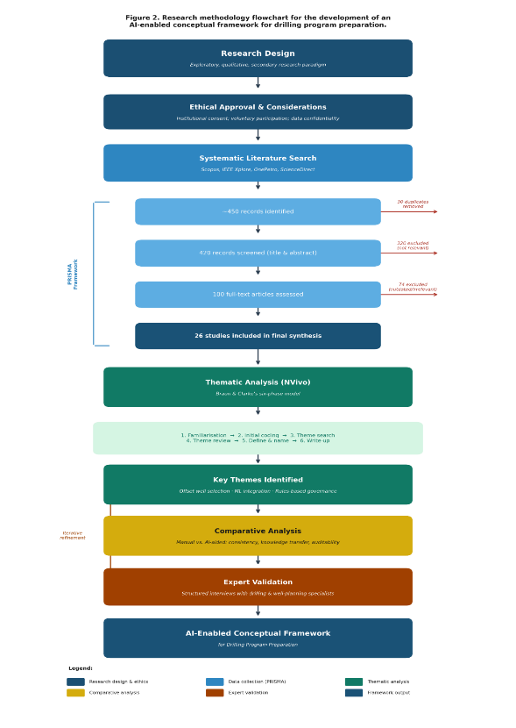
Figure 3 The PRISMA-guided literature selection procedure is represented in the left bracket and the amount of exclusion at each phase. Colour coding separates the research design (dark navy), data collection (blue) and thematic analysis (green), the comparative

Ethics in Research
The importance of ethics in any research work is also important in a study on human subject directly or on secondary literature. Ethical consent has also been taken in this study and agreed upon prior to the involvement of any industry practitioners or taking any form of feedback. The step will ensure that the research satisfies both the institutional ethical standard and an interest to carry out research in a responsible manner (Bryman, 2016).
Although the primary data collection in the specified research will primarily rely on the secondary one, encompassing journal articles, conference papers, and industry reports published, the validation stage of the framework will presuppose the structured interview with the drilling and well-planning specialists. During this stage, the suggested framework will be presented to the participants in order to provide feedback on its clarity, feasibility, and relevance to the real process of planning. To protect the rights and the interests of such participants, there are different ethical in place. One, it is entirely voluntary and the participants may leave any time without one stating the reason. Second, they receive informed consent before any set of feedback is given and the aim of the study is made clear, the data is being used is also made clear and measures to guarantee the confidentiality of the information are made (Saunders, Lewis, and Thornhill, 2019). Third, no personal data, proprietary well identifiers and commercially sensitive data are obtained during the consultation. The interaction is strictly confined to the framework, reason, and viability of the proposed framework against a specific operational data of a company or an individual.
Other than guarding the participants, the study is also ethical in regard to conscionable use of second-hand information. All sources that were used in the literature review have been cited and referred to as per the academic standards. All the information is neither produced nor modified to support the results and the evaluation is conducted in an open manner that allows having an independent verification. Besides, the proposed framework is presented as a decision-support system, but not a decision-making system. This distinctiveness is very important in that it ensures that the professional responsibility and engineering judgment will not be delegated to the framework and any automated process but the human engineers. This is a moral stand that is maintained throughout the process of conducting the research and all the interaction processes captured in the documentation.

The Methodology

Description of research Design
The research design used in the study is the qualitative and exploratory research design. Exploratory design is applicable in the case when the research objective is to explore the issue, which is not completely covered in the literature and define a new meaning or a model based on the available evidence (Saunders, M., Lewis, P., and Thornhill, A. (2019)). However, based on what is established in the literature review, much of the aspects of machine learning to predict the parameters of drilling, offset well analysis and rule-based governance have been considered in isolation, but no current literature has offered a systematic end-to-end process of implementing all these in a single process of planning. This ambiguity justifies an exploratory methodology that tries to create such a framework at its fundamental basis basing on the trends and findings suggested in the published works.
The research is based on both secondary and primary data. The secondary data is provided by academic journals, conference papers, and industry reports that are published. The primary data is collected amongst drilling and digital professionals through structured interviews and questionnaire survey. The combination of the two kinds of data makes the study more solid, since the secondary data give the theoretical background, whereas the primary data help to verify the practicality and usefulness of the framework in actual operations (Creswell, J. W., and Creswell, J. D.). (2018)).

Data Collection Methods
Secondary Data
The information utilized in this study is collected on the form of systematic and structured review of the available scholarly and industrial literature. The search strategy is based on the PRISMA framework that offers a clear and repeatable way of finding, filtering, and choosing the sufficient studies (Page, M. J., et al. (2021)). The databases utilized are the Scopus, IEEE Xplore, the OnePetro and the ScienceDirect databases which are the most notable databases to conduct research in engineering and technology within the oil and gas industry. Some of the search terms include the AI in well planning, digital well planning, offset well analysis, machine learning drilling parameters, Bayesian optimisation drilling, drilling risk transfer and rules-based systems engineering, which are the key word phrases.
The query on these databases gave out about 450 records. After deleting 30 of the records that were noted to be duplicates, the rest of the records of 420 were narrowed down in regards to their titles and abstracts in order to ascertain the relevance of the records to the research questions. Such screening allowed cutting the 300 records to 100 that were further narrowed down through reading their contents more closely. The last category of the primary synthesis is a total number of 26 studies that formed the foundation of evidence of the literature review and the development of the conceptual framework (Vishnumolakala, N. (2022)).
The collection of the data was achieved by examining the industry reports, the technical guidelines and white papers of the large oil and gas operators and service companies besides the journal articles and the conference articles. These sources were rather convenient in providing the practical background and real life examples to the academic literature and in ensuring that the framework under consideration is grounded in the practical reality rather than theoretical literature (Petrofac.). (2024)).
Primary Data: Expert Interviews
The proposed conceptual framework was to be proven by conducting structured interviews with industry professionals. The sample population included the drilling engineers and digital or AI professionals who were directly engaged in the planning of wells and in making the operational decisions. The interviews were structured i.e. all the interviewees were asked the same set of questions and in the same order. The responses can be compared to the participants and the strategy is similar (Bryman, A.). (2016)).
The interviews were also focused: they had to obtain the expert feedback on the proposed AI-based drilling framework. The participants were taken through the framework diagram and requested to comment on the design, logic and usefulness in practice. Two sets of professionals were identified in order to find out the rationale behind the decision of offsets, risk transfer procedure, and planning output are pragmatic, reflect the actual operational needs and digital or AI professionals, to find out whether the AI components, including machine learning models and rules engine, were sound in nature and well-built.
The interview questions were designed based on six key areas namely, the logic of making the choice of the offset well, automatic extraction of risks in line with daily reports on drilling, preliminary recommendations of the parameters, according to the AI, the rules-based governance engine, the overall balance between automation and human control, and the greatest risks or unaddressed aspects of the framework. The purpose of the study was explained to all the participants prior to the interview. Participants were volunteers and anonymous. No proprietary information existed on the well or company specific operation statistics of the company that was sought which was well within the ethical considerations in Section 3.2.
Primary Data Survey Questionnaire
In addition to the expert interviews, a structured survey was dispatched to drilling engineers as a method of getting wider feedback on the framework relevance in practice. The questionnaire was developed to investigate their opinions regarding ten key points in the suggested framework using the five-point Likert scale of Strongly Disagree, Strongly Agree. Drilling engineers who are familiar with well program preparation also formed the target population.
This survey was administered online using Google Forms and the target population was to get at least 25 drilling professionals to respond to the survey. The acceptable responses obtained were 22 which is considered reasonable in such conceptual validation study. The responses are analysed and presented in Chapter 4. The fact that both the interview and survey methodology are combined ensures that the framework is not merely tested in terms of the theoretical standards, but also what the engineers that would be using it would want it to be like (Saunders, M., Lewis, P., and Thornhill, A. (2019)).

Data Analysis Techniques
Thematic Analysis (Secondary Data)
The thematic analysis is a relatively trendy method of qualitative research that encompasses recognition, coding and elucidation of sense patterns in a data set through the assistance of the information embodied in the literature review (Braun, V., & Clarke, V. (2006)). The thematic analysis is the most appropriate to the situation because it does not permit the researcher to summarise the individual researches but in the real sense, to develop the underlying themes and the relationship between different pieces of evidence that are intertwined. This is required to create a conceptual framework since the framework must possess the ability to synthesize the data of different disciplines in a model of reasoning and system.
The thematic analysis that is used in the research is based on the six-phase model by Braun, V., and Clarke, V. (2006). The former is the familiarisation of the data by the researcher as he reads and reads the documents he/she selected to have a complete picture of the subject matter of the research. The second one is that of formulation of initial codes that are short names that reflect significant concepts or ideas in the data. The third one is theme-hunting that involves clustering the similar codes into higher-order themes. The fourth step involves a revision and adjustment of the themes so that it is consistent and can be used in the data. The fifth and sixth steps involve defining and writing up of findings respectively. Thematically analysis is conducted under NVivo qualitative data analysis software (figure4) which helps in the rigour and efficiency of thematic analysis (Bazeley, P., and Jackson, K. (2013)).
Qualitative Content Analysis (Expert Interview)
The analysis of the responses of the expert interviews was conducted using qualitative content analysis. All the answers were read and coded based on the critical areas of the interview questions. Where there was an agreement of the professionals or similar issues were raised, that was pooled as a common discovery. In cases where the specialists held special or incongruent views, these were highlighted as important nuances. The results of the interview are presented in Chapter 6.

Descriptive Statistical Analysis (Survey)
Simple descriptive statistics are applied to analyse the survey data. The figures and percentage of respondents who provided each of the options as Strongly Disagree, Strongly Agree etc. are ascertained and summarised against each question. The overall tendency in the answers is used to find out the agreement of the drilling engineers with the idea, that the proposed framework is a solution to the real problems in their current working process. This plan is in line with a common use of survey information in engineering studies where conceptual models are to be verified (Creswell, J. W., and Creswell, J. D. (2018)).
3.3.4 Interview Protocol, NVivo Validation, and Survey Mapping
Interview Protocol
The interview protocol was designed to ensure that expert feedback was directly connected to the proposed drilling program framework rather than general views on artificial intelligence. Each participant was first introduced to the framework diagram and its main components, after which the discussion was guided using structured questions focused on key areas such as offset well selection, extraction of historical risks, parameter recommendations, and the role of safety rules. This approach allowed the researcher to evaluate each part of the framework individually while maintaining a clear link to the overall system. Two groups of experts were involved, including drilling engineers and digital or AI specialists, to capture both operational experience and technical feasibility. All interviews were conducted face-to-face, which enabled clarification during the discussion and helped generate more detailed, experience-based insights. This method ensured that the feedback was practical and directly relevant to the development and refinement of the proposed framework.
NVivo Validation
The interview responses and selected literature were analyzed using thematic analysis supported by NVivo software figure 4. The coding process began by identifying key ideas related to the research objectives, including data challenges, risk identification, model application, and governance. These codes were then reviewed and grouped into broader themes that reflect the structure of the proposed framework. To iimprove the reliability of the analysis, the coding process was repeated and compared across different data sources, including literature and expert feedback. Differences in expert opinions were retained and considered as meaningful findings rather than removed, as they highlight practical challenges and limitations. This approach ensured that the final themes were not only consistent but also grounded in both theory and practice, providing a strong basis for the framework design (Braun & Clarke, 2006; Bazeley & Jackson, 2013).

Survey Mapping
The survey was developed to support the qualitative findings by collecting feedback from a wider group of drilling engineers. Each survey question was linked to a specific component of the framework, such as challenges in offset selection, difficulty in identifying historical risks, acceptance of AI-generated recommendations, and the importance of safety validation. This structured mapping ensured that the survey results could be directly used to evaluate the relevance and practicality of each framework module. By aligning the survey design with the research objectives and framework structure the responses provided targeted evidence rather than general opinions.This strengthened the overall analysis by confirming whether proposed framework addresses real operational challenges identified by practitioners (Creswell & Creswell, 2018).

Comparative Analysis
To further justify the methodology, comparative analysis is added to the research design. Such methodology will be used so as to make comparisons between the traditional, manual approach to the drilling program development and the proposed AI model. By the comparative analysis of these two approaches, the study demonstrates that there are some areas where the conceptual framework would add some value particularly on areas of time efficiency, data consistency and risk reduction.
The comparative analysis is made on the basis of three criteria:
- Process Consistency: When compared to a manual interpretation by individual engineers, examination of the variability of the manual interpretation is a comparison with less heterogeneous output of a rules-based AI selection.
- Knowledge Transfer: Compared to the manual process of locating the offset reports, the automated collection of previous signal history (Amount of mud loss in such a section, what type of BHA).
- Auditability: Measuring the ease of the traditional and proposed digital workflow with respect to the capability of tracking the decisions applied to the planning process to source data.
The logical rationale of the creation of the framework is provided through this comparative strategy. It assists in ensuring that the proposed solution does not transform into an easy technological supplement to the existing manual procedures that are cited to be ineffective. The outcomes of this comparison are the background of the validation stage in Chapter 5.

ANALYSIS
This chapter interprets the evidence gathered for the study and shows how that evidence answers the two research questions. The conceptual findings in Sections 4.2 to 4.4 come mainly from Chapter 2, especially the themes on digital well planning, hierarchical offset selection, machine learning for drilling parameterand rules-based governance. The survey findings in Section 4.5 come from the primary data process described in Chapter3 where the questionnaire design, respondents, and descriptive statistical approach were explained. Chapter 4 therefore links the theoretical foundation in Chapter 2 the research process in Chapter 3, and the framework developed in Chapter 5.The analysis indicates that the proposed framework is not centred on automation alone. It addresses a practical planning difficulty: drilling engineers often spend valuable time searching for offset wells, reviewing old reports, and trying to recover lessons that already exist but are not organised for quick reuse. The findings point to three needs: better offset selection logic, better data structure, and stronger governance over AI-generated outputs. In addition, qualitative insights from the literature and survey responses were supported through thematic structuring using NVivo, which assisted in identifying recurriing patterns related to offset selection, data challenges, and governance requirements.
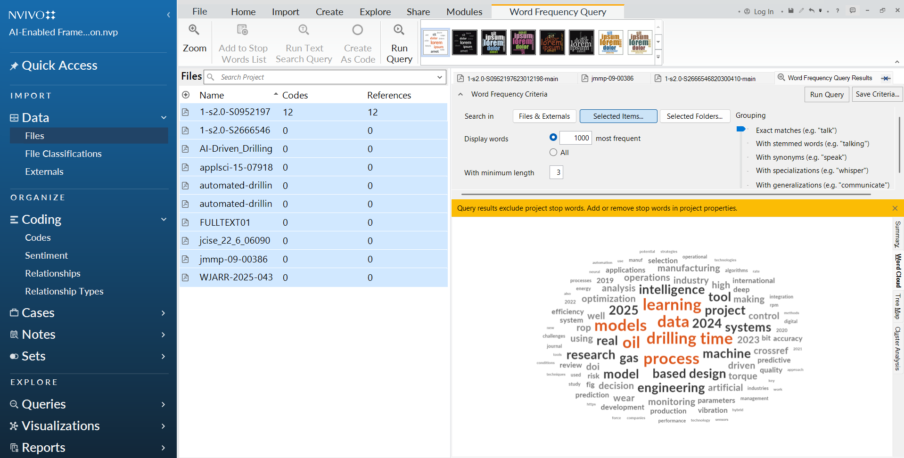
Figure 4 Word Cloud

The Industrial Need and Conceptual Foundation
The analysis of the research codes revealed that industrial demand was too much on the need to move towards the "Smart Oilfield." The statistics show that much is already being wasted within the industry by wasting invisible time, lack of data of experts. According to Williams (2022), the inability to identify high-quality labeled datasets is also the initial impediment to improving the application of AI to engineering design as discussed in chapter 2. In addition, according to the research by Adjei (2025) and Sircar (2021), discussed in chapter 2. Manual planning is no longer sufficient in the depth of the contemporary reservoirs. According to the statistics, even such giant players in the market as Shell and Chevron have already achieved efficiency gains of up to 130 percent through the implementation of AI-enhanced optimization models. The most interesting outcome of this analysis is also the role of the professional that is also changing, as defined by Koroteev (2021) as the transformation of the engineer. The data refer to the fact that AI does not replace the engineer but rather only alters his or her work to the extent where he/she can now be an AI manager and be capable of focusing on making the high-level decisions, rather than data searching with a great deal of effort chapter 5.

Data Integration and Hierarchical Connectedness
To provide answers to the first research question on how offset wells are systematically utilized, data identification and processing had been analyzed. This information verifies that scientifically most reasonable procedure to select hierarchy offset is the one, which is unable to discriminate the similarity of reservoirs and subsequently the provisions of spatial radius. It is essential to mention that to execute an AI structure, Williams (2022) indicates that the historical report must be transformed into machine-readable forms and standard forms of metadata as discussed in chapter 2. Without this transformation, AI systems cannot effectively analyze historical failure of operations (stuck pipes or circulation losses). The other notable finding of the analysis was that there was an urgent need of what is referred to as a cyber-physical pathway. This programming fibre links the planning document with the actual real-life rig protocols and hardware interfaces. Khan (2025) explains that the adherence to technical standards like the WITSML and OPC-UA would be a viable solution in ensuring that the parameters that were employed during the planning phase would be compatible with the physical rig equipment at the wellsite.

Artificial Intelligence Regulations of Governance and Modeling
To respond to the second research question that is regarding consistency and quality the analysis took into account interaction between machine learning and engineering rules. The facts point to the fact that the combination strategy is superior to the application of single algorithms. Mohammadinia (2025) states that Gradient Boosted Trees are highly fruitful in the role of learning models to predict the speed of penetration, whereas on the one hand, reinforcement learning and Bayesian Optimization is required to keep these parameters within the harmless work ranges as discussed in chapter 2. A critical implication is that AI cannot be implemented to manage safety related operations in the oil and gas sector by itself. It demonstrates that a rules-based engine of governance must be considered the last gatekeeper, as demonstrated by Mertiri (2025) and Gao and Sun (2023). This engine applies corporate safety standards and regulatory limits that provide the traceability and structural completeness that a manual program may not provide. Besides, the threat of algorithmic bias and conceptual drift is also detected in the process of analyzing Povooas (2025), hence the need to monitor the model at all times to maintain the model structure as both ethical and technically sound over an extended period.

Table 1Comparative synthesis of literature findings and implications for the proposed framework
Theme | Evidence drawn from Chapter 2 | Main limitation in prior studies | Implication for Chapter 5 framework
Digital well planning | The review linked AI adoption to efficiency, reduced NPT, and better use of historical knowledge. | Most studies describe digital progress broadly but do not convert it into a full planning workflow. | The framework should be presented as a practical planning system, not only a technical idea.
Offset selection | Relevant studies supported reservoir-based relevance before simple proximity. | Manual selection remains subjective and many studies stop at analogue identification. | Offset wells should be ranked by reservoir first and distance second before downstream analysis begins.
Prediction and optimisation | The literature justified the use of predictive ML together with optimisation under constraints. | Most models address one task at a time and are not connected to the final planning document. | AI modules should support parameter estimation and optimisation, but as part of one linked workflow.
Rules-based governance | Several studies argued that safety-criticaldrilling decisions require explicit engineering rules. | Governance is often discussed conceptually and not embedded into model outputs. | A rules engine should checkrecommendations against standards before engineer review.

Comparative Synthesis:
The comparative logic outlined in Chapter 3 explains why this matters in practice. Manual planning can still produce strong results, but quality depends heavily on who performs the work, how much time is available, and whether historical lessons are located and interpreted consistently. A governed AI-supported workflow does not remove engineering responsibility, but it reduces variation in selection, extraction, and checking.

Survey Results
A survey was developed to supplement the secondary literature analysis by interviewing drilling engineers on their perception of the problem of the existing manual planning process and whether the proposed AI framework would solve the problems. The questionnaire had ten items with a five-point Likert scale. Professionals in drilling were surveyed and gave 22 answers. Below, the findings will be summarized into three themes, namely, the current issues in manual planning, the practicality of particular features of framework, and the general worth of the framework.

Existing Problems with Manual Planning
Question 1: Minutes spent in searching data manually
The respondents were required to answer questions on whether they take a lot of time manually searching and examining historical offset well data. The results showed that 8 respondents Agreed and 8 Strongly Agreed bringing the total agreement to 72.7 percent. Strongly Disagreed and Disagreed only 4 and 1 respectively. This is in support of a direct and consistent literature conclusion: data hunting becomes a factual load and a time-consuming cost to the drilling engineers.
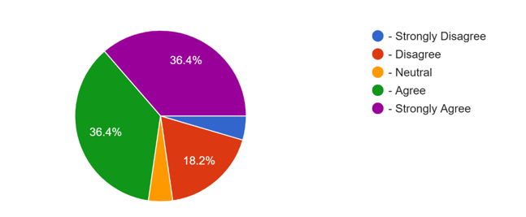
Figure 5 Searching data manually
Question 2: The subjectivity of the selection of offset wells.
Responding to the question of whether not or whether or not the selection of offset wells is subjective and may vary among the engineers when selecting the same new well, 11 respondents Agreed and 4 Strongly Agreed and gives an agreement rate of 68.2. There were only 6 Disagreed and 1 was Neutral. This is to advance the argument that there is inconsistency in the current manual process, and that there exists a need to have some form of structured selection hierarchy. This is an observation that is consistent with the problems raised in the literature where manual planning is extremely reliant on individual experience and judgment.

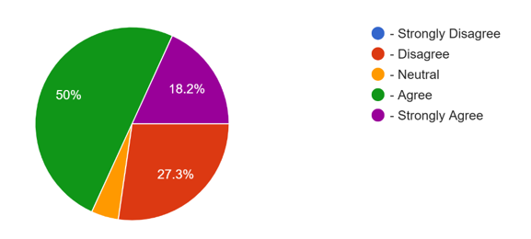
Figure 6 s=Selection of offset wells

Question 3: Difficult to get historical risks
The respondents were questioned on whether it is difficult to systematically draw out major risks like stuck pipe or circulation losses that were reported in the past in a new plan. This was the highest rate of consensus of all questions to be challenged: 11 Agreed and 7 Strongly Agreed with the overall agreement rate being 81.8%. The number of Disagreed and Neutral was only 3 and 1 respectively. This result directly confirms one of the main issues that this study will address, and coincides with the literature finding that the risks that have been identified are rediscovered rather than avoided during the planning stage.
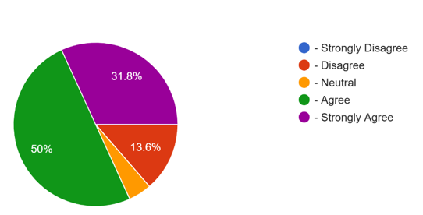
Figure 7 Historical Risks

Applicability of the Specific Frameworks Features
Question 5: Automatic risk flagging on the daily drilling reports
The participants were asked to answer questions regarding usefulness of the automatic flagging of historical risks involved in daily report work at various depths of a new plan. 10 Agree and 8 Strongly agree, with 81.8% total agreement. 4 Discords and no one was a Neutral type i.e. there was no gray zone between the two extremes i.e. respondents either agreed or disagreed on this feature. This is a strong result that supports the value of the NLP founded risk extraction component of the framework.
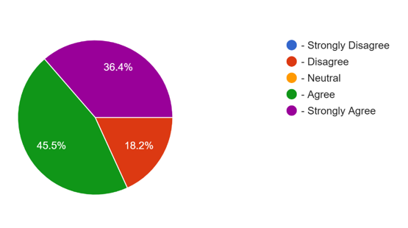
Figure 8 Automatic Risk Flagging

Question 8 Liberating engineers to concentrate on judgment and not data
Since the respondents were inquired about whether an integrated workflow would allow them to spend more time on engineering judgement and less on data hunting, 9 Strongly Agreed and 8 Agreed, which amounts to 77.3% of the respondents agree. 4 dissented and 1 was Neutral. The observation would align with the thesis statement that AI should be used to assist, but not replace, the engineer and represents the overall trend in the industry as described in the literature of human-AI planning, and not full automation.
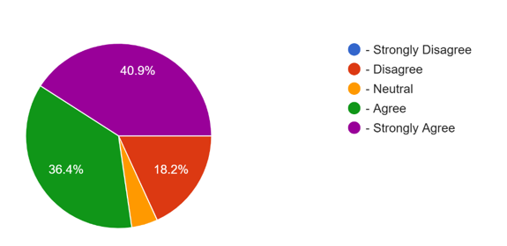
Figure 9 Liberating engineers to concentrate on judgment and not data

Table 3 Summary of Survey Findings
Q# | Topic | % Agree or Strongly Agree
1 | Time spent on manual data hunting | 72.7%
2 | Subjectivity in offset selection | 68.2%
3 | Difficulty extracting historical risks | 81.8%
4 | Hierarchical offset ranking tool | 77.3%
5 | Auto-flagging historical risks | 81.8%
6 | AI-generated parameter recommendations | 81.8%
7 | Auto-verification against safety rules | 81.8%
8 | Focus shift to engineering judgment | 77.3%
9 | Traceable outputs for audit | 77.3%
10 | Overall improvement in planning quality | 81.8%

PROPOSAL FOR AN AI-ENABLED FRAMEWORK
Even though, the proposed framework is hypothetically developed to be inclusive of all the twelve technical areas required by a drilling program- this study narrows down to
three key areas of high impact. The specific modules are selected to provide the study with a direction and ensure that the research approach becomes narrowed down and can be measured and qualified in line with the available manual provisions.

The area of central focus in this study is:
- Automated Offset Well Selection: Replacing manual searches (that are subjective) with a hierarchical and multi-criteria similarity analysis.
- NPT and Risk Extraction of Daily Operations Reports: Replacing active planning (reading past programs) with a proactive step, which is reading daily operational reports and learning what past problems (e.g. stuck pipes, losses) actually happen that will not be reflected by the planned programs.
- Optimized Casing and Mud Program Design: Bayesian Optimization and Machine Learning to the two most significant technical elements of the project to ensure that they are coordinated and safe, which are now highly diverse between the engineer-to-engineer.
These three areas will enable the study to quantify the benefits on time savings, consistency on the basis of the data and the risk awareness compared to the more traditional manual-based practices with the highest degree of accuracy.

Framework Development

AI Back-End Multi-stage Processing Workflow
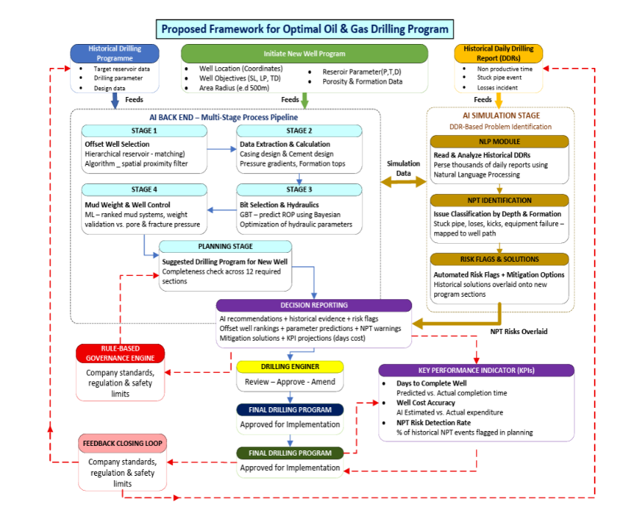
By the framework architecture of the AI back-end, it is processed on a multi-stage processing pipeline with structure. One stage is fed on some input data and the output data feeds on other stages and downstream planning modules. The workflow is as follows:

Input Stage: Data Ingestion:
The engineer feeds the target well position figures (latitude, longitude), significant reservoir factors like porosity (P), temperature (T) and depth (D) and a search radius about the target (e.g. 500 metres). The AI back-end is triggered by the inputs that are entered into the system.
Stage 1: Geological Algorithm and Offset Well Selection:
The algorithm is hierarchical reservoir-matching algorithm that initially consults wells within the identical geological structures and reservoir characteristics and the spatial radius filter ranks the offset wells based on their distance. This will form a geologically and operationally most relevant standardised list of the offset wells (AWE -Automated Well Evaluation Preparation).
Stage 2: Data Extraction and Calculation of parameter:
Depending on the offset wells, which will be picked, the system will retrieve the past drilling parameters that include casing logs, completion logs, formation tops and performance indicators of the undertakings. Systematic calculations that give the most important calculations (count of returns, casing setting depths, and pressure gradients) are made on the basis of extracted data.Stage Stage 3: Mud Weight Inquiry and Well Control Test:
The framework questions the historical mud programmes of the similar offset wells, retrieves the mud systems, which were most performing, and cross verifies mud weight propositions against pore pressure forecasts and fracture gradient forecasts to ensure that there are adequate well control margins.
Stage 4: Comparison and Check of Completeness and Planning Sheet Generation:
All the parameters that have been extracted and optimised are summarised into one planning sheet. It carries out a completeness check of the twelve required sections of a standard drilling programme and where the information is insufficient or where there is need to apply engineering judgment is denoted. The result is a Decision Report that internalizes the AI suggestions and historical evidence of the suggestions.

Problem Implementation and Simulation Step DDR-Based
Parallel to the multi-stage pipeline, the framework also executes another special Daily Drilling Report (DDR) analysis module. This module is linked with the historical database of DDRs of the selected offset wells and applies the algorithms of Natural Language Processing (NLP) to the identified issues that had been registered, the NPT events, and the operational problems on specific depths and formations.
The problems mentioned are classified and ranked by type (stuck pipe, losses, kicks, equipment failure), depth interval, and formation and overlaid onto the new-created well plan as automated risk flags. This is the Simulation Stage of the framework because the AI models the potential problem areas, by superimposing the data of the past occurrences over the intended well path.
Feedback Loop Mechanism
The feedback loop is extremely important element of the framework as shown in the architectural design. When drilling programe is implemented and actual drilling of the well is in progress, the real data of operation: the final Daily Drilling Reports, the actual costs and the time it took to complete, the number of the NPT events incurred is inputted into the database of the historical data. This feedback enhances the data to be employed in the future in an offset well query so that the AI models can evolve to the current operational outcomes and continue to enhance the accurateness of the predictions and recommendations to the future wells of the identical field or formation.

5.3 Offset Well Selection
Manual Practice: The engineers search through databases of historical wells records, manually, finding the offset well in terms of personal knowledge, position and available records. It is also time-consuming and fails to provide similar results among engineers hence reference wells selection to the same planned site is not uniform.
AI Conversion: The structure will entail automated and hierarchical well offset well selection module where queries of initially wells in the same reservoir and then followed by a determined spatial range is sought and interrogated in case the wells are not located in the determined spatial range. It will also ensure that the individual requirement is never adopted to determine the most geologically and operationally viable wells (Feng and Han, 2015). The engineer puts in the target well coordinates and a search radius (e.g. 500 metres) and the AI back-end Stage 1 algorithm delivers a ranked list of offset wells filtered by reservoir match and spatial proximity which is directly inputted to all downstream planning modules.

Casing Design Parameters
Manual Practice: Engineers can determine the casing setting depths, size, grade, and design loads by manual calculation to burst, collapse, and tension basing their decision on the calculated profiles of the expected pressure and the anticipated downhole condition. Various safety factors or design assumptions can be used by every engineer.
AI Conversion: The model input is the parameters of casing design of successful offset wells under the same pressure and geological setting, and it applies Bayesian Optimisation to determine optimal casing designs within safe operating space provided by company specifications and regulatory guidelines. The rules engine uses minimum design requirements and complete structure checks to provide recommendations to the engineer (Teixeira and Secchi, 2019).

Drilling Mud Program
Manual Practice: The engineer determines the requirements made by the mud weight, the fluid that will be employed, specifications of the treatment and even compatibility with the equipment by examining the formation properties, the anticipated pressures, and having a previous experience with similar formations. The choice is normally determined by the personal preference and a prescribed understanding of the application of particular mud systems.
AI Conversion: The systematically accessed mud program data of the offset wells, which drilled in the same formations, which mud system had the highest success according to the hole stability and effectiveness of drilling, and suggests the most desirable mud properties, according to the machine learning models. The governing rules are such that rules of the recommended mud weight ensure that there is an adequate well control margin without fractured formation strength (Al-Rubaii et al., 2023). The module relates to Stage 3 of the AI back-end pipeline where the queries of mud weight are compared with the pressure prediction queries of Stage 2.
- 5.6 Bit Selection and Hydraulics
- Manual Practice: The choice of the bit is made according to the performance record of the neighboring wells, formation drillability, mud system compatibility and directional requirements. The computation of hydraulics of annular velocity, Bit horse power hydraulic and jet impact is performed manually.
- AI Conversion: The model is anchored on the historical record of bit performance on offset wells and is used to predict the type of bit most suitable and each section of the hole hydraulics. The Rate of Penetration of different combinations of bits and parameters is estimated with the help of Gradient Boosted Trees and the maximisation of the number of parameters leading to the safe drilling operation is determined through the application of Bayesian Optimisation (Mohammadinia et al., 2025).

NPT Prevention and Risk Identification
- Manual Practice: At present engineers primarily examine the completed " Drilling Programs of past wells to identify risks. But these programs do not portray what happened but what should have happened. In case an issue such as a clogged pipe arose, it could be buried in a mountain of thousands of pages of handwritten or typed Daily Drilling Reports (DDRs). This is Active Planning--it adheres to a plan but it usually lacks real life challenges that are encountered by the former crew.
- AI Conversion: Natural Language Processing (NLP) is used to convert the framework to Proactive Planning. NLP is an intelligent technology based on AI that is capable of reading and comprehending thousands of Daily Drilling Reports within several seconds. The AI does not examine the old plan but scans the real-life comments of past engineers on a daily basis to determine where and why Non-Productive Time (NPT) occurred.
When these lessons learned are discovered based on real world information on a daily basis, the system automatically recognizes threats like specific depths in which the company incurred a loss and immediately inserts them into the new program. This would ensure that the engineer would be made aware of the actual facts of history and not optimal plans and the new well would be much safer (Salem et al., 2022). This module is based on the DDR historical database and supplies its results to the Simulation Stage where the NPT patterns identified are overlaid on the planned well path as depth-specific and formation-specific risk indicators.
- 5.8 Human controls and Regulatory Governance
The most critical thing about the proposed framework is that all outputs obtained by an AI are processed by a rules-based governance engine, which is presented to the drilling engineer. Such an engine will also make sure that the company drilling standards, regulatory requirements, and safety constraints are followed. It also does structural completeness to determine that all the required areas of drilling program are addressed. The framework does not give final rulings and does not pursue any business. All the outputs should have their recommendations revised, approved or modified by qualified engineers who shall be fully accountable of the professional responsibility in the final drilling program. This is the extent of governance by the proposed framework, as compared to the full autonomy systems, and ensures that the benefits of AI are realized in a regulated and auditable engineering scenario (Arinze et al., 2024).

5.9 Problem Solution Workflow and Decision Report
The framework leads to a Decision Report that is the compilation of all AI-generated recommendations, historical data, and risk flags into a report that is now ready to review by the drilling engineer. The Decision Report will include:
- Ranking of offset well locations on justification statistics (reservoir match score, distance)
- Past confidence intervals of the expected drilling variables.
- NPT risks that were identified were used on the depths and formation of the planned well.
- The recommended solutions to the mentioned problems are pegged on the successful mitigation procedures articulated in the historical DDRs of the same offset wells.
- KPI projections like days to complete projections, cost forecasts which were compared against offset wells actuals.
The engineer will discuss the Decision Report, make a professional decision and approve / amend the recommendations and sign the final drilling programme. Any alterations as may be made by the engineer are documented to allow the engineer to trace them and are sent back into the system to feed the later suggestions.

VII. DISCUSSION AND THEORETICAL IMPLICATIONS

From Fragmented AI Point Solutions to Integrated Rule-Based Governance
This paper shows that there is a need to be developed in terms of the application of digital technology in the drilling sector. Historical artificial intelligence and machine learning in drilling have been considered point solutions, meaning, one specific task, i.e. the rate of penetration, or when a pipe is stuck. Even though these tools are very helpful, they are at times isolated and the engineers have to fill the gap between the various results manually. This conceptual framework created in this study is dynamic and thus changes this by providing an umbrella design due to which these individual tools are co-ordinated. The validation phase discussion with the industry authorities confirmed that the true value of AI should not be limited to its predictive capacity, but should have the capacity to organize and present the past in such a format which can be acted upon by an engineer in the planning capacity in an immediate manner.
One of the most important lessons that were made during this work is the importance of the hierarchical offset selection logic. The existing analog planning theories suggest that proximity is the major consideration to be made when choosing offset wells. Yet this framework was developed and constructed and indicated that the geological relevance, which is the connectivity of reservoirs, must be viewed as the priority of what simple geographic distance can provide. This provides a twist into the traditional neighbor proximity strategy. Paying attention to the wells that lead to the same reservoir, the AI framework will be capable of making the parameters proposed by the AI framework, such as the mud weights and depths of the casing reliant on the most relevant physical conditions, rather than on the closest values available. It was found that this hierarchy reduces the noise of irrelevant data that is a common problem in mature fields where hundreds of wells can be located within a small area.
Besides, a rules-based engine of governance also addresses a key theoretical gap in AI-based studies. Majority of machine learning models have been criticized as black boxes where the logic behind a prediction can be not seen. A black-box solution is not accepted by the top management in such a high-stakes situation as the oil and gas drilling, when one misstep can lead to the environmental disaster or the loss of money on a massive scale. This is replaced by the structure discussed herein, which has an open rules engine as the final filter. This causes any AI-generated suggestion to be checked against a predetermined safety standard and regulation. It has a two-layered model that is rooted in machine learning to optimize and rules to be safe; it is new and trustworthy. It is also aligned with the idea of human-in-the-loop AI in which the technology will act as a complement to the expert, rather than replace him or her.
To further support the discussion quantified estimation of the expected performance improvements of the proposed framework is presented. Based on survey findings and expert feedback, the framework is expected to reduce drilling program preparation time by approximately 30% to 50%. This is mainly due to automation of offset well selection and structured extraction of historical data which addresses inefficiencies commonly associated with manual data searching and report review (Rahman et al., 2023; Petrofac, 2024). In addition the framework is expected to improve planning completeness and consistency by approximately 20% to 30% as the rules based governance layer ensures that all required elements of the drilling program are systematically validated rather than depending on individual experience (Gao & Sun, 2023; Arinze et al., 2024).
From a risk management perspective the integration of automated extraction of historical events from Daily Drilling Reports is expected to increase early stage risk identification by approximately 40% to 60%, particularly for non productive time events such as stuck pipe and losses. This is consistent with previous findings that highlight the lack of systematic risk transfer in conventional planning workflows (Amani et al., 2024; Salem et al., 2022). In a simulated planning context, this would lead to a higher probability of identifying known failure zones before execution, reducing the likelihood of repeated operational issues. Although these values are based on conceptual estimation rather than field implementation, they provide a realistic indication of the framework’s expected impact on efficiency, quality, and risk awareness.

To further demonstrate the alignment between the research problem, objectives, and research questions Table4 provides a structured mapping of how each element has been addressed throughout the thesis.

6.3 Reflection on Research Questions
The initial research question was how the use of the offset wells in a typical reservoir or a certain radius could be concerned in the planning parameter and risk determination in a systematic manner. The paper found that the most appropriate of this is by a hierarchical selection process. The framework is able to automatically create casing points, mud weight envelopes and historical non-productive time events first of all, by filtering on the basis of the reservoir and secondly by filtering on the basis of spatial proximity. The study has shown that the omission of lessons present in the manual planning is avoided by the planned extraction. The AI can also make all of the historical events visible and offer them as a risk annotation, which would not happen in case an engineer would not look at a report that was written five years ago. It is an answer to the first question because it provides an automated logic of transferring data.
The second research question was what was the degree to which a structured framework is more superior to manual preparation in terms of consistency, traceability and quality. The comparative analysis and the analysis of the experts made it possible to determine that the improvement is significant. No one is also objective as manual planning because the same data on offsets may be interpreted differently by the various engineers depending on their experience. The homogeneityof the reasoning is introduced by the AI system. As the system uses the same rules and algorithms on all wells, the programs obtained in the process would be the same in all parts of the organization. There is also a high amount of traceability. The tendency in manual is that an individual may not be aware as to why a certain amount of weight of mud was chosen. In the proposed scheme, all the parameters are linked to either a specific offset well or a rule to be followed, and therefore there would be an evident audit trail. This determines the fact that the framework to a great extent enhances the standard and dependability of the drilling program.

Integration of Primary Data Findings

Expert Interview Findings
The structured interview conducted with a drilling expert gave first hand practical feed back on the framework proposed. The general evaluation of the expert has proven to be positive and there is proof that the framework was well-organized and comprehensive. However, some of the key observations were made that have shaped the final version of the framework.
The expert accepted that hierarchical offset selection strategy is more reliable and justifiable since by this method, first hierarchically by reservoir, and then hierarchically by spatial proximity, removes the more tedious and arbitrary existing selection techniques, which are manual. This goes to the point of directly confirming the Research Question 1 that needed to determine the way the utilization of offset wells can be conducted in a systematic manner in order to obtain planning parameters and risks. The hierarchical organization was described to reduce bias, make the logic of selection transparent or easier to be explained during the peer review or audit. This is in line with the literature argument that relevance of reservoirs be accorded a higher priority than that of the geographic distance when selecting offset wells. (2023).
Answering the question whether it is possible to scan daily drilling reports using Natural Language Processing and determine whether some issues have been detected before at some depths, the professional stated that such a measure would go a long way in eliminating the repetition of problems. The history of the many issues is already captured in reports and they are rarely reconsidered systematically in the planning process. This is because when these risks are seen in the planning process and not found in the implementation, institutional learning and risk mitigation is improved. This corroborates the findings of the literature according to which the systematic transfer of risk based on the information of offset is among the most significant missing links in the traditional planning processes (Amani, M., et al. (2024).
On AI-generated initial parameter recommendations, the expert accepted that there is high value in offset performance successful to create initial recommendations on casing points, mud weights, and bit selection. The expert, however, noted that such outputs can be regarded as preliminary assumptions, as opposed to the final engineering decisions particularly in cases where there is geomechanical complexities. This substantiates the selection of the framework design to make AI outputs present itself as recommendations that can be discussed by the engineer rather than as solutions. (2023).
The AI expert confirmed that the automatic checking against the company standards and safety envelope of AI findings would significantly increase the consistency and reduce the chances of the presence of loopholes in compliance that can be achieved due to time constraints. This takes the work of engineers out of the normal compliance check as far as higher level engineering judgment where human expertise can add the most value. This is in line with the literature that proves the existence of a required rules engine to support safety constraints and provide traceability in AI-assisted planning (Al-Dushaishi, M. F., and Al-Sofi, H.). (2025).
Data quality and contextual interpretation was also the most significant risk of the framework as determined by the expert. The language of Daily Drilling Report might be incoherent, incomplete, or vague. Inability to explain clearly the confidence levels, assumptions, and gaps in the data in the system may lead to excessive trust in the system outputs by engineers. This feedback is now socialized in the framework design that now obviously requires transparency indicators and AI-generated advice.
Some of the structural recommendations that the specialist gave included restructuring the arrangement of the elements of the framework. The specialist suggested the following correct flow to be: AI Recommendations -Rule-Based Governance -Engineer Review - Final Program. This ensures that the engine of governance is used as a filter to the engineer looking at the output and not as a parallel or secondary process. This conducted in a systematic manner in order to obtain planning parameters and risks. The hierarchical organization was described to reduce bias, make the logic of selection transparent or easier to be explained during the peer review or audit. This is in line with the literature argument that relevance of reservoirs be accorded a higher priority than that of the geographic distance when selecting offset wells. (2023).
Answering the question whether it is possible to scan daily drilling reports using Natural Language Processing and determine whether some issues have been detected before at some depths, the professional stated that such a measure would go a long way in eliminating the repetition of problems. The history of the many issues is already captured in reports and they are rarely reconsidered systematically in the planning process. This is because when these risks are seen in the planning process and not found in the implementation, institutional learning and risk mitigation is improved. This corroborates the findings of the literature according to which the systematic transfer of risk based on the information of offset is among the most significant missing links in the traditional planning processes (Amani, M., et al. (2024).
On AI-generated initial parameter recommendations, the expert accepted that there is high value in offset performance successful to create initial recommendations on casing points, mud weights, and bit selection. The expert, however, noted that such outputs can be regarded as preliminary assumptions, as opposed to the final engineering decisions particularly in cases where there is geomechanical complexities. This substantiates the selection of the framework design to make AI outputs present itself as recommendations that can be discussed by the engineer rather than as solutions. (2023).
The AI expert confirmed that the automatic checking against the company standards and safety envelope of AI findings would significantly increase the consistency and reduce the chances of the presence of loopholes in compliance that can be achieved due to time constraints. This takes the work of engineers out of the normal compliance check as far as higher level engineering judgment where human expertise can add the most value. This is in line with the literature that proves the existence of a required rules engine to support safety constraints and provide traceability in AI-assisted planning (Al-Dushaishi, M. F., and Al-Sofi, H.). (2025).
Data quality and contextual interpretation was also the most significant risk of the framework as determined by the expert. The language of Daily Drilling Report might be incoherent, incomplete, or vague. Inability to explain clearly the confidence levels, assumptions, and gaps in the data in the system may lead to excessive trust in the system outputs by engineers. This feedback is now socialized in the framework design that now obviously requires transparency indicators and AI-generated advice.
Some of the structural recommendations that the specialist gave included restructuring the arrangement of the elements of the framework. The specialist suggested the following correct flow to be: AI Recommendations -Rule-Based Governance -Engineer Review - Final Program. This ensures that the engine of governance is used as a filter to the engineer looking at the output and not as a parallel or secondary process. This repositioning has found its reflection in the new framework diagram in Chapter 5.

6.4.2 Survey Results and Implications
The general quantitative confirmation of the framework is the survey results of 22 drilling engineers. The overall mean agreement was approximately 78 in all ten questions and no question had lower average than 68. These results provide a substantial support that the framework will discuss real operation loopholes identified by practising engineers.
The results confirm the validity of the data hunting problem in that 72.7 percent of the participants have affirmed that they devote a lot of time in the manual search of past offset data as discussed in chapter 4. This goes hand in hand with the fact that in the literature it is observed that drilling engineers spend disproportionate time of their planning time in finding offset wells and reading old reportages instead of conducting engineering analysis. (2023)). The fact is that, the subjectivity of the offset option was confirmed by only 68.2 percent of the respondents, which is the lowest of all questions as shown in chapter 4. It is an implication that engineers are mostly aware of the inconsistency problem, but can think that their personal practice is consistent enough. This is among the potential adoption barriers: engineers who think that they do a good and efficient job will be less motivated to have different attitudes.
The maximum consensus of 81.8% was reached in four features, i.e. automatic extraction of historical risks, parameter recommendation defined by AI, automatic checking of safety rules, and the idea of the overall framework. The fact that most of the respondents agreed with the safety rule checking option almost unanimously (81.8 per cent agree, zero neutral) is the evidence that this tier of governance is not only theoretically correct but is sought after by the practitioners in practice. This confirms the literature observation that a rules engine offers the structural completeness and traceability that is not available to manual planning at the moment. (2023).

IMPLICATIONS FOR PRACTICE AND FUTURE RESEARCH
There is a need to have a good appreciation of the weaknesses and the strength of any solution proposed to re-align the oil and gas industry between the abstract theory and the implementation in the real world. This chapter will give the practical implication of the study on energy companies and drilling engineers based on the findings of the literature review, the professional interview and the survey of the drilling experts. It also outlines the limitations of the study that was conducted and gives suggestions on how the limitations can be overcome. Lastly, the chapter presents the possible future research directions which may involve the creation of a functional software prototype and the incorporation of real-time drilling data into the planning process.

7.2 Implications for Practice
The results of this study have direct and obvious implications on the drilling teams and digital transformation leaders in oil and gas organisations. The hypothesis that there is a high level of practical demand among the engineers who would be the users of the proposed structured AI-assisted planning tool is proven by the results of the survey which showed that on average 78 percent of the interviewed believed that the proposed framework features would be valuable to their work. (2023)). The highest scores of the agreement were achieved in automatic risk extraction of daily drilling reports, automatic recommendation of parameters by AI and automatic checking of safety rules. This informs organisations that it is these three features that need to be given priority in every implementation roadmap.
The expert interview affirmed this by confirming that the greatest real-life benefit of the framework that would be realized fastest would be the removal of time spent on hunting data to enable the engineers to redirect their efforts to a more advanced level of technical analysis and judgment. The expert also noted that the traceable audit trail that the framework would leave behind linking all the recommendations to their source data, ML output, and rule of governance would make programs far simpler to audit and justify in the peer review or regulatory audit. This traceability aspect is adequate in organisations where the circumstances are highly regulated to signify a profound improvement in the current manual documentation procedures (Al-Dushaishi and Al-Sofi, 2025).
The framework can also offer an efficient model of uniformity of quality of planning between locations and teams to digital transformation leaders. This is because the same selection rules and algorithms will apply to all the wells hence the quality of output will not depend on the level of experience of the specific engineer who will be sent to work on the assignment. It is particularly applicable in those organisations, which have many fields/region coverage and cannot easily be consistent in planning through manual means (Petrofac, 2024).

7.3 Limitations and Recommendations
Although the proposed framework has its strong sides, a number of limitations should be mentioned. To begin with, the framework is theoretical and methodological nowadays. It is a description of the logic of the working process, data interactions, and model roles, not working software code or a user interface. This means that its practical implementation, when time limits and incomplete information are involved, and complex geological conditions, are not yet practical.
The framework assumes that historical well files are electronic format, reasonably complete and in a regular format. Practically, the older well records might only be in the form of manual reports or of low quality scans, which cannot be processed by the AI systems without a lot of pre-processing. This was the greatest threat to the success of the framework that the expert interview had found because any system not equipped with the ability to communicate with the engineer the degree of confidence, gaps and assumptions in data is one that is at risk of over-reliance on the outcomes of a system that is driven by incomplete or inconsistent source data partially.
The third limitation, which is indirectly stated by the survey results, is that there may be resistance towards adoption. Although 68.2 percent of the surveyed people consented that the procedure of an offset selection is subjective and inconsistent (the lowest point of all questions), it is noteworthy that some percentage of engineers consider that their current individual practice is adequate. The organisations implementing this framework should not anticipate that all people will buy-in instantly.
To address these weaknesses, organisations have been encouraged to undergo a data purification effort first before any AI implementation. Past reports are to be digitised and standardised with the help of natural language processing software so that the AI has a solid and stable knowledge base to operate on. The introduction of the framework should also take place in stages and not as a wholesale replacement of the current planning processes. In the first step, one can suggest offset wells and mark historical risks through the system and provide the engineers with time to gain some familiarity and trust before the automated parameter recommendation layer is introduced. Training is also crucial: engineers should comprehend the reasoning of the AI proposals to be able to observe the system efficiently and take action in case the situation of geological or operational factors is too far to the right of the historical data (Gao and Sun, 2023).

7.4 Future Work
The next most important thing that this research must undertake is the creation of a fully operational software prototype. An operational digital tool, which would be founded on the conceptual model, would allow conducting a mass back-testing of thousands of historical wells, feeding the machine learning algorithms with real performance data, and estimating the real decrease in the time of planning and the number of failures. This would also allow testing the framework with the specified problems of data quality as one of the limitations which would be empirically tested as to how effectively the NLP-based risk extraction component can process inconsistent or incomplete legacy reports.
The further study will need to take into account the application of more advanced examples of AI such as the Reinforcement Learning that would allow the system to learn as the outcomes of the programs it helps to produce. This would eventually result in a self-refining planning mechanism that would be more accurate and reliable as every well was drilled. At present, this type of feedback loop is not present in any of the point solutions known in the literature review (Allawi et al., 2025).
The second crucial aspect that may be enhanced in further work is the implementation of real-time drilling data in the planning organization. The current system is geared towards the pre-spud planning process. However, a dynamic system that ensures the drilling program is updated as the drilling is being done would be an enormous jump. As an example, in the case of a well hitting a pressure zone above the model, the AI could automatically recalculate the data on the appropriate offset and propose a new mud weight or casing depth in real-time, therefore, reducing response time and increasing well control. Finally, more research could look into how the framework could be extended to incorporate the objectives of environmental and social governance and make AI achieve the maximum optimization of the minimization of a carbon footprint and regulatory adherence to the traditional engineering principles of cost and speed.

CONCLUSION
The purpose of this thesis was to make and test a theoretical AI-based system to plan the drilling programs in the oil and gas industry. The motivation to carry out the research was that conventional process of well planning is very manual and labour intensive and involves a lot of dependence on experience of individual engineers. Such a process is usually dependent on human memory and manual search of historical information, and therefore can result in an inconsistent plan, the loss of important historical risks, and repetitive operational failures. This thesis explored the latest trends within the area of artificial intelligence, surveyed how the industry was already operating, and collected the first-hand evidence by conducting professional interviews and a systematic survey, which led to the systematic and evidence-based resolution of these problems.
The framework as elaborated in the study is related with three basic innovations in the field of well delivery. Firstly, it is associated with a hierarchical principle of choosing the offset wells in which the geological factors, i.e., the connectivity of reservoirs, is valued more than the geographic distance (Gao and Sun, 2023). This ensures that the information that is used to make decisions on new wells reflect the actual picture of what is happening in the subsurface environment and not the nearest one available. Second, the framework is a hybrid of predictive and optimisation machine learning models to determine the parameters Gradient Boosted Trees and optimisation of the values to the safest and most efficient ones under constrained limits (Mohammadinia et al., 2025; Teixeira and Secchi, 2019). The integration will bring the system to a stage that is not only data retrieval but more of the optimal parameter envelope that is grounded on performance and safety. Third, a business engine of governance offers the required control to make sure that all recommendations produced by AI are verified against corporate principles, regulatory standards, and limits of safety before they are forwarded to the engineer to be reviewed finally (Al-Dushaishi and Al-Sofi, 2025).
The validation of the framework was done by two primary data collection methods, and the two methods produced strong and consistent results. The expert interview with a drilling specialist proved that the hierarchical offset selection logic is more sensible and explainable than the current manual processes, automatic risk warning, based on daily drilling reports, would come in handy, and the rules-based engine of governance would make the plans better, requiring less effort on the part of engineers to check compliance with rules on a routine basis and elevate the level of their judgment. The other highly important structural recommendation given by the expert was the fact that the appropriate flow must make the governance engine precede the engineer review and not a parallel process, as was incorporated in the final framework design. The survey of 22 drilling engineers who responded to the survey was also used to support these findings as they concurred on all the ten questions about 78 percent on average. The greatest support with 81.8% agreement was automatic risk extraction, AI-generated parameter recommendations, safety rule verification and the concept of the framework. These findings affirm that the framework is able to fill veritable and well-known gaps in existing planning processes (Rahman, M., Ahmed, S., and Khan, R.). (2023)).
The paper also confirms that the future of the drilling program preparation is in the combination of artificial intelligence and human engineering judgment. The framework will not replace the drilling engineer but empower them with a traceable, data-driven and structured toolset. The framework offers the complete benefit of the available experience in history by systemising the experience of past operations to such that it may be readily available and memorable. This is in concurrence with the greater aim of digital transformation in the energy sector that is to have safer, efficient and predictable well delivery processes. As the industry advances and wells become increasingly complex and costly, organisations will need conceptual integrated models of the kind in order to continue delivering quality in their planning and reduce recidivism failures as well as remain competitive in a progressively data-driven operational environment.

REFERENCES

- Adjei, K. Y., Odor, G. E., Nurein, S. A., Ogu-Opara, P. C., Ugwu, O. C., Owunna, I. B., & Virginia, E. O. (2025). Optimizing well placement and reducing costs using AI-driven automation in drilling operations. World Journal of Advanced Research and Reviews, 25(2), 1029–1038.
- ADNOC. (2024). ADNOC and AIQ accelerate deployment of industry-first AR360 AI solution. https://www.adnoc.ae/en/news-and-media/press-releases/2024/adnoc-and-aiq-accelerate-deployment-of-industry-first-ar360-ai-solution
- Al-Dushaishi, M. F., & Al-Sofi, H. (2025). Drilling optimization using artificial neural networks and field data from southern Iraq. Energies, 9(2), 37. https://doi.org/10.3390/en09020037
- Allawi, R. H., Al-Mudhafar, W. J., Abbas, M. A., & Wood, D. A. (2025). Leveraging boosting machine learning for drilling rate of penetration (ROP) prediction based on drilling and petrophysical parameters. Artificial Intelligence in Geosciences, 100121.
- Al-Mudhafar, W. J., Wood, D., Al-Obaidi, D., & Wojtanowicz, A. (2023). Well placement optimization through the triple-completion gas and downhole water sink-assisted gravity drainage (TC-GDWS-AGD) EOR process. Energies, 16(4), 1790.
- Al-Qattan, A., & Al-Shammari, M. (2023). Learning from offset wells to optimize drilling programs in carbonate reservoirs [Paper presentation]. SPE Middle East Oil & Gas Conference. https://doi.org/10.2118/214101-MS
- Al-Rubaii, M., Al-Shargabi, M., & Al-Shehri, D. (2023). Hole cleaning during drilling oil and gas wells: A review for hole‐cleaning chemistry and engineering parameters. Advances in Materials Science and Engineering, 2023(1), Article 6688500.
- Amani, M., et al. (2024). Challenges in automated drilling program generation. Petroleum Exploration and Development, 51(2), 340–355.
- Amani, M., et al. (2024). Intelligent well planning: AI-supported decision workflows for complex wells [Paper presentation]. SPE Annual Technical Conference and Exhibition. https://doi.org/10.2118/215004-MS
- Aneke, A., & Eteyen, O. E. (2024). Enhancing operational efficiency in Nigerian oil exploration: The impact of real-time monitoring technologies on non-productive time. Journal of Sustainable Development of Transport and Logistics, 9(2), 43–52.
- Arinze, C. A., Izionworu, V. O., Isong, D., Daudu, C. D., & Adefemi, A. (2024). Integrating artificial intelligence into engineering processes for improved efficiency and safety in oil and gas operations. Open Access Research Journal of Engineering and Technology, 6(1), 39–51.
- Baquero Rico, N. C. (2021). Risk assessment for blowouts and kicks in oil and gas wells during drilling activities: A review [Unpublished manuscript or Thesis].
- Bazeley, P., & Jackson, K. (2013). Qualitative data analysis with NVivo. Sage Publications.
- Black, J., & Murray, A. D. (2019). Regulating AI and machine learning: Setting the regulatory agenda. European Journal of Law and Technology, 10(3).
- Braun, V., & Clarke, V. (2006). Using thematic analysis in psychology. Qualitative Research in Psychology, 3(2), 77–101.
- Bryman, A. (2016). Social research methods. Oxford University Press.
- Chen, F., Sun, L., Jiang, B., Huo, X., Pan, X., Feng, C., & Zhang, Z. (2025). A review of AI applications in unconventional oil and gas exploration and development. Energies, 18(2), 391.
- Creswell, J. W., & Creswell, J. D. (2018). Research design: Qualitative, quantitative, and mixed methods approaches. Sage Publications.
- Deziel, N. C., Clark, C. J., Casey, J. A., Bell, M. L., Plata, D. L., & Saiers, J. E. (2022). Assessing exposure to unconventional oil and gas development: Strengths, challenges, and implications for epidemiologic research. Current Environmental Health Reports, 9(3), 436–450.
- Díaz, E., & Spagnoli, G. (2024). Gradient boosting trees with Bayesian optimization to predict activity from other geotechnical parameters. Marine Georesources & Geotechnology, 42(8), 1075–1085.
- Elekhteiar, M., et al. (2025). Reduction of non-productive time through digital well planning. SPE Drilling and Completion, 40(1), 88–102.
- Epelle, E. I., & Gerogiorgis, D. I. (2020). A review of technological advances and open challenges for oil and gas drilling systems engineering. AIChE Journal, 66(4), e16842.
- Feng, G. Y., & Han, J. X. (2015). The oilfield production prediction model based on principal component analysis and least squares support vector machine. Computer Knowledge and Technology, 11(31), 144–147.
- Feng, Y., & Han, Z. (2015). Hierarchical well similarity analysis for offset selection. Journal of Natural Gas Science and Engineering, 27, 1535–1545.
- Gao, W., & Sun, R. (2023). Knowledge-driven drilling recommendations using case-based reasoning and operational history. Engineering Applications of Artificial Intelligence, 122, 106078. https://doi.org/10.1016/j.engappai.2023.106078
- Hanif, H. R. (2024). The role of artificial intelligence in optimizing oil exploration and production. Eurasian Journal of Chemical, Medicinal and Petroleum Research, 3(5), 176–190.
- Haouel, C., & Nemeslaki, A. (2024). Digital transformation in oil and gas industry: Opportunities and challenges. Periodica Polytechnica Social and Management Sciences, 32(1), 1–16.
- Hassanvand, M., Moradi, S., Fattahi, M., Zargar, G., & Kamari, M. (2018). Estimation of rock uniaxial compressive strength for an Iranian carbonate oil reservoir: Modeling vs. artificial neural network application. Petroleum Research, 3(4), 336–345.
- Hersum, T. (2023). Subsurface data and AI in Equinor. Equinor. https://www.equinor.com/energy/data-in-equinor
- Ibrahim, M. O. (2004). Computer application-electro mechanical systems (Doctoral dissertation). Dublin City University.
- Johnston, M. P. (2017). Secondary data analysis: A method of which the time has come. Qualitative and Quantitative Methods in Libraries, 3(3), 619–626.
- Khan, Z. (2025). Automated drilling process control using artificial intelligence: A novel framework for unconventional reservoirs and fracking operations. International Journal of Engineering Research & Technology (IJERT), 14(12), 1–15.
- Koroteev, D., & Tekic, Z. (2021). Artificial intelligence in oil and gas upstream: Trends, challenges, and scenarios. IEEE Access, 9, 163107–163119.
- Mertiri, S. (2025). Artificial intelligence in project selection in process industries: Enhancing prioritization, risk management, and decision-making [Master's thesis, Stockholm University]. DiVA Portal.
- Mohammadinia, F., et al. (2025). Rate of penetration prediction in drilling operations via machine-learning frameworks. Journal of Petroleum Science and Engineering, 6(2). https://doi.org/10.1007/s13202-025-02020-9
- Ochoa, D. (2024). Drilling automation and innovation. Journal of Petroleum Technology, 76(2). https://jpt.spe.org/drilling-automation-and-innovation-2024
- Page, M. J., et al. (2021). The PRISMA 2020 statement: An updated guideline for reporting systematic reviews. BMJ, 372, n71.
- Petrofac. (2024). Digital well delivery and data-driven planning. Petrofac Technical Paper Series. https://www.petrofac.com
- Póvoas, M. S., Moreira, J. F., Martins Neto, S. V., Carvalho, C. A. S., Cezario, B. S., Guedes, A. L. A., & Lima, G. B. A. (2025). Artificial intelligence in the oil and gas industry: Applications, challenges, and future directions. Applied Sciences, 15(14), 7918.
- Prestidge, K. L. (2022). Digital transformation in the oil and gas industry: Challenges and potential solutions (Doctoral dissertation). Massachusetts Institute of Technology.
- Rahman, M., Ahmed, S., & Khan, R. (2023). Challenges in conventional drilling program preparation workflows [Paper presentation]. SPE Asia Pacific Oil and Gas Conference, Paper SPE-215234.
- Rahman, M., Ahmed, S., & Khan, R. (2023). Machine-learning-assisted drilling performance prediction and decision support. SPE Journal, 28(2), 455–468. https://doi.org/10.2118/212345-PA
- Salem, A. M., Yakoot, M. S., & Mahmoud, O. (2022). Addressing diverse petroleum industry problems using machine learning techniques: Literary methodology—Spotlight on predicting well integrity failures. ACS Omega, 7(3), 2504–2519.
- Salem, A., et al. (2022). Systematic failure mapping from offset well operations. Reliability Engineering and System Safety, 223, 108–120.
- Saunders, M., Lewis, P., & Thornhill, A. (2019). Research methods for business students. Pearson Education.
- Shakirov, A., & Xie, Y. (2024). Machine learning-based drilling parameter prediction for real-time well control. SPE Drilling & Completion. https://doi.org/10.2118/214562-PA
- Shokouhi, S. V., Skalle, P., & Aamodt, A. (2014). An overview of case-based reasoning applications in drilling engineering. Artificial Intelligence Review, 41(3), 317–329.
- Sircar, A., Yadav, K., Rayavarapu, K., Bist, N., & Oza, H. (2021). Application of machine learning and artificial intelligence in oil and gas industry. Petroleum Research, 6(4), 379–391.
- SLB. (2025). Eni using digital, AI, and automation to drill beyond limits. https://www.slb.com/resource-library/case-study-with-navigation/di/eni-using-digital-ai-and-automation-to-drill-beyond-limits
- Teixeira, A., & Secchi, A. (2019). Machine learning models to support reservoir production optimization. IFAC-PapersOnLine, 52(1), 498–501.
- Vishnumolakala, N. (2022). Downhole intelligence for drilling systems using supervised and deep reinforcement learning techniques (Doctoral dissertation).
- Wang, Z., Li, S., Jin, Z., Li, Z., Liu, Q., & Zhang, K. (2023). Oil and gas pathway to net-zero: Review and outlook. Energy Strategy Reviews, 45, 101048.
- Williams, G., Meisel, N. A., Simpson, T. W., & McComb, C. (2022). Design for artificial intelligence: Proposing a conceptual framework grounded in data wrangling. Journal of Computing and Information Science in Engineering, 22(6), 060903.

