Algorithmic Trust and Choice Liquidity: A Dual-Pathway Framework for AI-Mediated Consumer Decision Architecture
Dr. Markus Rach
Canadian University Dubai
markus.rach@cud.ac.ae

https://doi.org/10.63962/JDFF2455

Abstract—This conceptual paper proposes a dual-pathway framework explaining how artificial intelligence recommender systems reshape consumer brand evaluation and choice behavior. Integrating trust transfer theory, brand equity frameworks, and consideration-set research, two interacting pathways are proposed, a traditional brand-equity route and a novel AI-mediated route, and choice liquidity is introduced as a structural construct capturing the algorithmically driven reconfiguration of consideration sets across purchase episodes. Choice liquidity is formally differentiated from consideration-set volatility, brand switching, and exploration in recommender systems. Seven hypotheses address trust transfer, substitution and amplification effects, and contextual moderation. A compressed longitudinal design is outlined as the vehicle for future empirical evaluation.
Keywords—AI recommender systems, trust transfer, brand equity, consideration sets, choice liquidity, algorithmic mediation

I. INTRODUCTION

A. Context and Problem
Artificial intelligence (AI) recommender systems (RS) have become structural features of digital commerce, operating across e-commerce, media streaming, banking, and social platforms. By learning from behavioral data, they generate personalized recommendations that reduce consumer search costs. Empirical research demonstrates that when consumers perceive an RS as accurate, transparent, and personalized, trust in the system transfers to recommended products and brands, a mechanism grounded in trust transfer theory [1].
Simultaneously, branding theory conceptualizes brand equity as encompassing awareness, associations, and loyalty [2], a cognitive shortcut that facilitates decision-making and mitigates perceived risk [3]. Traditional consumer decision models assume a direct route from brand equity to purchase outcomes, a pathway designated as Path 1 in this paper’s framework. The emergence of AI-mediated recommendation introduces a parallel route: trust in the algorithmic system itself may transfer to, substitute for, or amplify pre-existing brand equity.

B. Research Gaps
Existing studies examine immediate post-recommendation trust outcomes without integrating AI trust and brand equity into a unified theoretical model [4], [6]. The longitudinal consequences of repeated algorithmic mediation on brand loyalty, switching, and market diversity remain theoretically underspecified. Evidence of echo-chamber effects in AI RS has not been integrated into branding or equity frameworks.
No construct captures the structural reconfiguration of consideration-set membership across purchase episodes, leaving a gap between single-episode trust studies and longitudinal market-diversity outcomes.

C. Contributions
This paper proposes three contributions to the existing body of knowledge. First, it conceptualizes a dual-pathway framework integrating trust transfer theory, brand equity, and consideration-set research. Second, it introduces choice liquidity as a structural property of AI-mediated decision environments. Third, it advances a compressed longitudinal experimental design as the empirical vehicle for addressing the absence of validated methods for capturing dynamic AI RS effects across consideration sets and brand equity simultaneously.

II. LITERATURE REVIEW
A search via consensus.app across 170 million papers yielded 1,130 results; 607 were screened, 351 met eligibility criteria, and 50 were included across eight targeted search groups covering trust transfer, consideration-set effects, brand equity, and echo-chamber dynamics.

A. Trust Transfer from AI to Brands
Trust transfer theory suggests that trust generalizes from one entity to a related entity when a meaningful connection is perceived [1]. Studies confirm positive spillover from AI recommender trust to brand trust; among Generation Z consumers, for instance, AI accuracy evaluations significantly enhanced brand trust and purchase decisions [4]. Voice assistant research confirms that system trust mediates shopping satisfaction through consideration-set adjustment [5].
Field experiments using causal mediation confirm that RS increase both the size and depth of actively considered options [6].

B. Brand Equity and Consideration Sets
Brand equity accrues through awareness, associations, and loyalty, reducing perceived risk and increasing the probability that a brand enters a consumer's consideration set [2]. The literature understands consideration sets as memory-based structures shaped by prior experience and marketing communications [7]. AI RS disrupt this architecture by foregrounding options which are outside consumers’ awareness [6].
While AI can expand consideration sets by surfacing novel alternatives, unconditional trust in AI leads consumers to default to recommended options, narrowing choice diversity. This echo-chamber dynamic, where high algorithmic trust reinforces rather than broadens consumption patterns [8], remains unaddressed in branding and equity frameworks.

C. Contextual Moderators
For hedonic products, human recommenders outperform AI due to mentalizing activation; for utilitarian purchases or with anthropomorphic cues, AI is comparably persuasive [9]. Consistent with dual-process theory, high-stakes decisions increase reliance on accuracy and transparency signals. Brand awareness has been shown to moderate RS trust transfer, with lower awareness amplifying and higher awareness dampening the effect [10].
Transparency and explainability emerge as critical levers: explainable AI demonstrably increases user confidence and calibrates reliance [11]. Trust calibration, the degree to which consumers regulate algorithmic guidance, moderates transfer magnitude and consideration-set composition [11].

D. Research Gaps and Theoretical Need
Three interconnected gaps emerge. First, no unified framework integrates trust transfer and consideration-set effects longitudinally. Second, while brand awareness has been tested as a moderator of AI RS effects [10], no framework models trust-level substitution versus amplification across the full range of brand equity levels. Third, no construct captures the structural reconfiguration of consideration sets under sustained algorithmic mediation. A fourth, methodological gap underlies all three: no validated design exists for isolating AI RS trust effects longitudinally across consideration sets and brand equity within a single study. These gaps collectively motivate the dual-pathway framework, the choice liquidity construct, and the compressed longitudinal design introduced in this paper.

III. CONCEPTUAL FRAMEWORK AND HYPOTHESES

A. Choice Liquidity: Definition and Differentiation
Choice liquidity is defined as the algorithmically driven reconfiguration of consideration-set membership across sequential purchase episodes, a latent structural property of the consumer's decision environment under sustained AI mediation.
Three distinctions to existing constructs are critical. First, although consideration-set volatility can encompass both size and compositional change, it remains a descriptive, episode-level observation agnostic to cause. Choice liquidity attributes the reconfiguration specifically to algorithmic mediation: membership shifts are structurally governed by repeated AI recommendation across a decision sequence, not by random search or volitional change. Consideration-set volatility is therefore a necessary but insufficient condition for choice liquidity.
Second, choice liquidity differs from brand switching: switching is a discrete transaction-level behavior; choice liquidity is the latent environmental condition that may or may not produce switching. A consumer can exhibit high choice liquidity, cycling through varied brand exposures across episodes, while maintaining identical final purchase behavior.
Third, choice liquidity differs from exploration in RS: exploration is a system-side design objective (algorithmic diversity injection); choice liquidity is the consumer-side outcome. The same exploratory algorithm produces high or low choice liquidity depending on whether the consumer's trust is calibrated or unconditional. This carries direct policy implications: welfare assessments must account for consumer-side response, not algorithmic intent alone.
Choice liquidity is bidirectional: expansion (new brands surfaced under high-transparency, accurate AI signals) and narrowing (reduced set diversity through default reliance under echo-chamber conditions). This bidirectionality distinguishes it from scalar quantity measures such as consideration-set size.

B. Dual-Pathway Framework
This paper proposes a dual-pathway framework (Fig. 1) with two interacting routes:
Path 1 – Brand-Equity Route (Traditional): Brand equity → purchase intention [2].
Path 2 – AI-Mediated Route: AI trust → brand trust (via trust transfer) → dynamic consideration set → choice liquidity → brand switching/loyalty.
Brand trust serves as the proximal driver of purchase outcomes in both routes: in Path 1 it operates through established brand associations [2], [3]; in Path 2 it is generated explicitly through algorithmic trust transfer [1]. The pathways interact through brand equity: high-equity brands experience amplification; low-to-medium equity brands experience substitution. Product type, perceived risk, anthropomorphism, transparency, and trust calibration moderate the relative strength of each pathway.
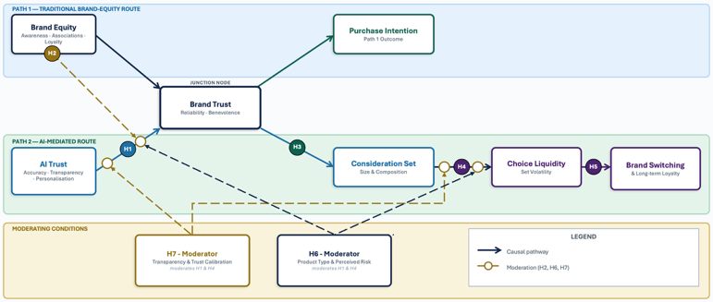
Fig. 1. Dual-Pathway Framework for AI-Mediated Consumer Decision Architecture. Solid arrows = causal paths; dashed arrows = moderation; ○ = moderation intersection points. In Path 1, brand trust operates implicitly through established brand associations; in Path 2 it is generated explicitly through trust transfer.

C. Hypotheses
Several hypotheses have prior empirical support. However, given the low replication rate in marketing studies [12], where prior empirical work exists, the proposed hypotheses also serve a replication purpose.

H1 (Trust Transfer): Trust in AI RS positively influences trust in the recommended brand.
H2 (Substitution vs. Amplification): The positive effect of AI trust on brand trust is stronger for low- and medium-equity brands (substitution) than for high-equity brands (amplification).
H3 (Consideration Set Expansion): Higher AI trust increases consideration-set size, mediated by trust in the recommended brand.
H4 (Choice Liquidity): Repeated reliance on AI RS increases choice liquidity, defined as volatility in consideration-set membership, which manifests as both expansion and echo-chamber narrowing.
H5 (Switching and Loyalty): Elevated choice liquidity increases short-term brand switching without reducing long-term category loyalty. H5 is proposed for future longitudinal research.
H6 (Moderation by Product Type and Risk): The substitution effect (H2) and choice liquidity (H4) are stronger for utilitarian products and high-risk purchase contexts than for hedonic products and low-risk contexts.
H7 (Trust Calibration): Transparency, explainability, anthropomorphism and user control moderate trust transfer and choice liquidity; calibrated trust reduces echo-chamber narrowing and promotes informed exploration.

IV. RESEARCH DESIGN

A. Design Overview and Novel Contribution
A compressed longitudinal experiment captures dynamic changes in trust, consideration sets, and brand switching across repeated decision episodes without multi-year deployment. Three innovations distinguish this design: (1) purchase occasions are simulated within one week, enabling longitudinal causal inference; (2) AI trust signals are manipulated experimentally, permitting clean identification of trust-pathway effects; and (3) validated survey scales, behavioral set-membership tracking, and information-theoretic diversity metrics are integrated within a single design.
Three hundred participants, stratified by age, gender, and digital literacy, are randomly assigned to conditions, satisfying thresholds for stable SEM estimation [13] and multilevel model power [14]. Although mediation and moderation are tested via regression-based path analysis [19], the structural complexity of the multi-level, multi-wave design, encompassing latent growth models and cross-level interactions, justifies the 300-participant threshold recommended for complex structural models [13]. Compressed simulation designs have demonstrated validity for capturing dynamic consumer choice [15]; participants therefore complete four purchase episodes at 48-hour intervals over one week.

B. Stimuli and Manipulations
Stimuli consist of two product categories, utilitarian (household consumables) and hedonic (premium confectionery), presented through a custom mock e-commerce interface (Fig. 2). The embedded AI engine varies three trust signal dimensions between subjects: transparency (explainable versus black-box), anthropomorphism (human-like avatar versus neutral interface), and stated accuracy (high precision versus unspecified). The three dimensions are administered as a composite condition, all signals present (high trust) versus all signals absent (low trust), yielding two trust-signal groups crossed with the calibration prompt factor to produce four experimental conditions of approximately 75 participants each.
Brand equity is manipulated through real and fictitious brand pairings, pretested for awareness and favorability. Half the sample receives trust calibration prompts; the other half serves as controls.

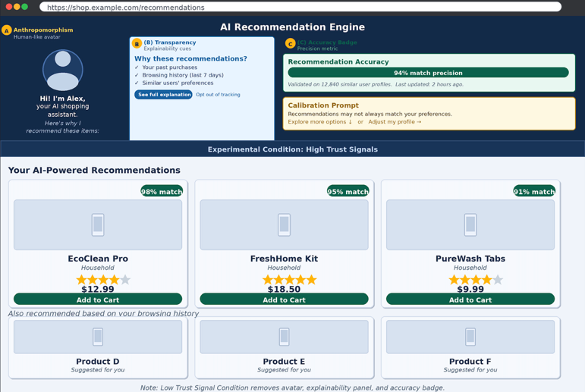
Fig. 2. Prototype Mock E-Commerce Interface (High Trust Signal Condition). Callouts (A)–(C): (A) anthropomorphism, (B) transparency/explainability, (C) accuracy badge. The low trust condition removes all three.

C. Construct Measurement
AI trust is measured using a validated multi-item scale [16]. Brand trust is assessed using an established consumer-brand trust scale [17]. Consideration-set size and membership are captured behaviorally as self-reported candidate sets per episode.
Choice liquidity is operationalized as: (1) within-subject variance in consideration-set membership across episodes; (2) proportion of novel brands introduced per episode; and (3) Shannon entropy of brand distributions, collectively distinguishing exploration from echo-chamber consolidation. The indirect effect of AI trust on consideration-set size via brand trust (H3) is tested using bootstrapped confidence intervals within the regression-based path analysis framework [19]. Multilevel mixed-effects models accommodate the repeated-measures structure [18]; regression-based path analysis tests the framework's hypothesized mediation and moderation paths [19]; latent growth models capture trajectories across episodes [20].

V. CONCLUSION
AI RS reshape consumer decision architecture by introducing an algorithmically governed trust pathway alongside traditional brand equity mechanisms. This paper proposes a dual-pathway framework integrating trust transfer theory, brand equity, and consideration-set research, and introduces choice liquidity, a formally differentiated construct capturing consideration-set reconfiguration under algorithmic mediation.
Seven testable hypotheses and a compressed longitudinal design provide a rigorous vehicle for future empirical evaluation. The framework bridges marketing, behavioral economics, and platform governance by treating AI as a structural feature of choice environments. For practitioners, transparency and calibration mechanisms are prerequisites for sustainable AI-mediated brand strategy. For policymakers, the model supports regulatory interest in algorithmic transparency, user control, and disclosure standards. Future research should implement the design across diverse cultural contexts and examine the interplay between AI recommendation and complementary trust mechanisms such as influencer endorsement.

REFERENCES
[1] D. Belanche, L. V. Casaló, C. Flavián, and J. Schepers, “Trust transfer in the continued usage of public e-services,” Inf. Manag., vol. 51, no. 6, pp. 627–640, 2014.
[2] D. A. Aaker, “The value of brand equity,” J. Bus. Strategy, vol. 13, no. 4, pp. 27–32, 1992.
[3] T. Erdem, J. Swait, S. Broniarczyk, D. Chakravarti, J.-N. Kapferer, M. Keane, J. Roberts, J.-B. E. M. Steenkamp, and F. Zettelmeyer, “Brand equity, consumer learning and choice,” Mark. Lett., vol. 10, no. 3, pp. 301–318, 1999.
[4] C. R. Guerra-Tamez, K. Kraul Flores, G. M. Serna-Mendiburu, D. Chavelas Robles, and J. Ibarra Cortés, “Decoding Gen Z: AI’s influence on brand trust and purchasing behavior,” Front. Artif. Intell., vol. 7, 2024. https://doi.org/10.3389/frai.2024.1323512
[5] A. Mari and R. Algesheimer, “The role of trusting beliefs in voice assistants during voice shopping,” in Proc. HICSS 2021. https://aisel.aisnet.org/hicss-54/in/ai_based_assistants/7
[6] X. Li, J. Grahl, and O. Hinz, “How do recommender systems lead to consumer purchases? A causal mediation analysis of a field experiment,” Inf. Syst. Res., vol. 33, no. 2, pp. 620–637, 2022.
[7] P. Nedungadi, “Recall and consumer consideration sets: Influencing choice without altering brand evaluations,” J. Consum. Res., vol. 17, no. 3, pp. 263–276, 1990.
[8] Y. Ge, S. Zhao, H. Zhou, C. Pei, F. Sun, W. Ou, and Y. Zhang, “Understanding echo chambers in e-commerce recommender systems,” in Proc. 43rd Int. ACM SIGIR Conf., 2020, pp. 2261–2270.
[9] A. H. Wien and A. M. Peluso, “Influence of human versus AI recommenders: The roles of product type and cognitive processes,” J. Bus. Res., vol. 137, pp. 13–27, 2021.
[10] W. Chang and J. Park, “A comparative study on the effect of ChatGPT recommendation and AI recommender systems on the formation of a consideration set,” J. Retail. Consum. Serv., vol. 78, p. 103743, 2024.
[11] D. Shin, “The effects of explainability and causability on perception, trust, and acceptance: Implications for explainable AI,” Int. J. Hum.-Comput. Stud., vol. 146, p. 102551, 2021.
[12] H. Evanschitzky, C. Baumgarth, R. Hubbard, and J. S. Armstrong, “Replication research’s disturbing trend,” J. Bus. Res., vol. 60, no. 4, pp. 411–415, 2007.
[13] E. J. Wolf, K. M. Harrington, S. L. Clark, and M. W. Miller, “Sample size requirements for structural equation models,” Educ. Psychol. Meas., vol. 73, no. 6, pp. 913–934, 2013.
[14] C. J. Maas and J. J. Hox, “Sufficient sample sizes for multilevel modeling,” Methodology, vol. 1, no. 3, pp. 86–92, 2005.
[15] R. R. Burke, B. A. Harlam, B. E. Kahn, and L. M. Lodish, “Comparing dynamic consumer choice in real and computer-simulated environments,” J. Consum. Res., vol. 19, no. 1, pp. 71–82, 1992.
[16] M. J. McGrath, O. Lack, J. Tisch, and A. Duenser, “Measuring trust in artificial intelligence: Validation of an established scale and its short form,” Front. Artif. Intell., vol. 8, p. 1582880, 2025.
[17] E. Delgado-Ballester, J. L. Munuera-Aleman, and M. J. Yague-Guillen, “Development and validation of a brand trust scale,” Int. J. Mark. Res., vol. 45, no. 1, pp. 35–53, 2003.
[18] S. W. Raudenbush and A. S. Bryk, Hierarchical Linear Models: Applications and Data Analysis Methods, 2nd ed. Thousand Oaks: Sage, 2002.
[19] A. F. Hayes, Introduction to Mediation, Moderation, and Conditional Process Analysis, 3rd ed. New York: Guilford Press, 2022.
[20] P. J. Curran, K. Obeidat, and D. Losardo, “Twelve frequently asked questions about growth curve modeling,” J. Cogn. Dev., vol. 11, no. 2, pp. 121–136, 2010.

